06 / INSTITUTIONAL PROJECT

Centralizing institutional stock movements, threshold alerts and reporting
A Laravel inventory portal built from administrative requirements to centralize products, movements, low-stock alerts and formal reporting.
STATUS | TEAM | DEMO | SOURCE
Academic delivery · Visual evidence pending | Solo internship project | Demo pending source recovery | Source not currently published

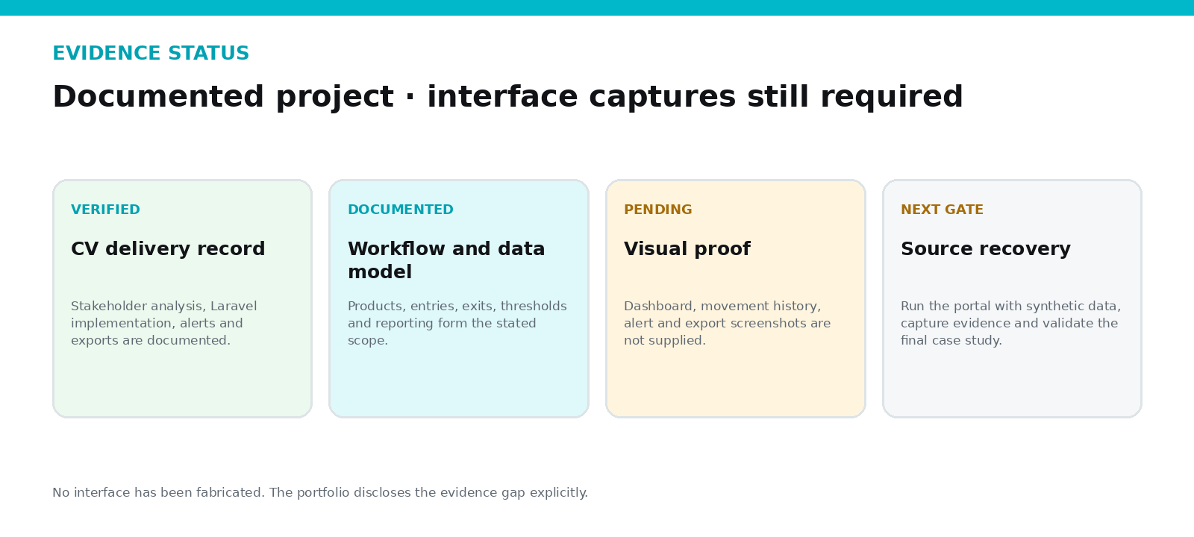
Evidence status map - no interface has been fabricated.
ANASS BENAMEUR · FULL-STACK PRODUCT ENGINEER

EXECUTIVE SUMMARY

The product, the problem and the proof
During a final internship at Faculté Chariaa in Fès, I built a stock-management portal directly from requirements gathered with administrative stakeholders — the kind of engagement where continuity and traceability matter more than visual polish, and where the requirements-gathering itself is half the engineering work.
Feb–May 2025  INTERNSHIP PERIOD | Full cycle  ANALYSIS TO DOCUMENTATION | Thresholds  CONFIGURABLE STOCK ALERTS | 2 formats  EXCEL AND PDF REPORTING

Context
A public university environment, where a stock system has to survive staff turnover and produce reports that satisfy an administrative audit trail, not just look good in a demo. Between February and May 2025, I worked directly with administrative stakeholders to define the requirements before writing a line of code.

My role and ownership
- Stakeholder requirements analysis
- Merise data modelling
- Laravel backend and Blade interface
- Functional testing
- Documentation and handoff preparation

Personal contribution
Requirements, modelling, implementation, testing and documentation.

PROBLEM

Why the existing workflow needed a system
Manual stock checking meant nobody could answer "how much do we actually have" without walking to the shelf. Low-stock situations were caught late because nothing was watching thresholds. And there was no single, reconstructable history of what entered and left inventory — exactly the kind of gap an administrative audit finds.

Before and after
BEFORE  • Manual or fragmented product records  • Stock levels checked reactively  • Movement history difficult to reconstruct  • Reports assembled separately  • Limited administrative visibility | AFTER  • Centralized product and stock records  • Entry and exit movement history  • Automatic threshold-alert logic  • Excel and PDF exports  • Documented institutional workflow

Meaningful result
Centralized movement history, threshold alerts and formal inventory reporting.

SOLUTION

How the system works
Products and movements share one relational core, modelled with Merise before a line of code was written and reviewed with the stakeholder group so the data model was agreed on, not just assumed. Configurable thresholds trigger alerts when stock drops below a set level per product, rather than relying on someone remembering to check manually.

Operational workflow
01  Product  Reference and category | 02  Entry  Quantity received | 03  Exit  Quantity issued | 04  Threshold  Low-stock alert | 05  Report  Excel / PDF history

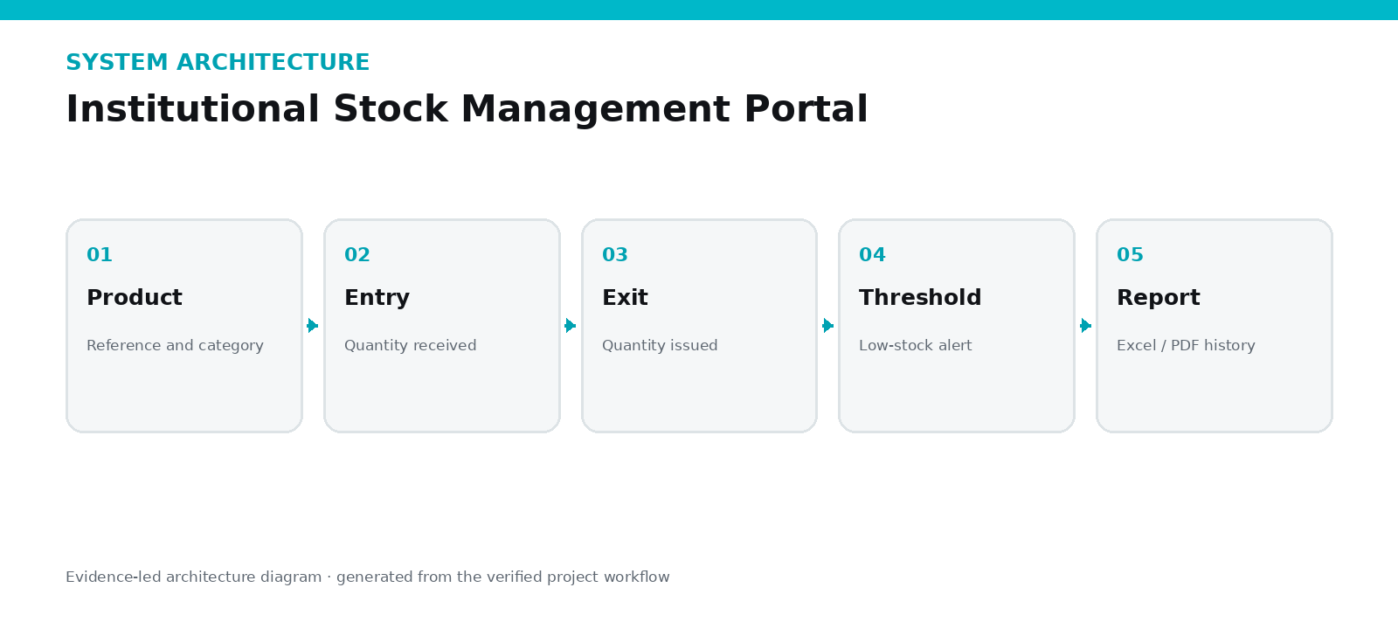
Every movement — entry, exit, adjustment — writes to a history that Excel and PDF reports generate from directly, so a printed report reflects the same data an administrator would see on screen, not a separately maintained summary that can quietly drift out of sync with reality. The lifecycle, step by step:

ENGINEERING

Architecture and decisions
The documented stack is Laravel, MySQL, Blade and MVC in a straightforward structure — the standard, unglamorous choice, deliberate for an institution that needs long-term maintainability over novelty. Requirements and data relationships were modelled with Merise before implementation began.

Critical engineering decisions
DECISION 01  Model movement history explicitly  Inventory must remain explainable through entries and exits rather than only a mutable quantity field. | DECISION 02  Thresholds as an operational control  Administrators need early warning instead of discovering shortages during a request.
DECISION 03  Formal export formats  Excel supports analysis while PDF supports stable administrative circulation. | DECISION 04  Document the complete lifecycle  Institutional adoption depends on requirements, testing and documentation as much as on code.

Technology stack
Laravel | PHP | MySQL | Blade | Merise | Excel / PDF

VISUAL PROOF

Evidence 1 of 1
Evidence map explaining what is verified and what remains pending.

OUTCOME

Value, proof and honest limitations

Operational impact
The delivered system gave the institution centralized product records, a reconstructable movement history, automatic low-stock alerts, and reports generated straight from the operational data instead of assembled separately — a complete requirements-to-documentation cycle over a February to May 2025 internship.

Verified evidence
- CV documents the internship, stack and complete delivery cycle
- Threshold alerts, movement history and Excel/PDF exports are consistently documented
- Requirements analysis and Merise modelling were part of the project
- Visual proof remains pending and is clearly disclosed

Current limitations
- No project screenshots were included in the supplied screenshot archive.
- No source archive or live runtime was supplied for independent verification.
- The project should not be presented as a final visual showcase until dashboard, movement, alert and export captures are added.
- No numerical impact is claimed without institutional measurement.

Current status
STATUS | TEAM | DEMO | SOURCE
Academic delivery · Visual evidence pending | Solo internship project | Demo pending source recovery | Source not currently published

WHY THIS PROJECT MATTERS
Centralized movement history, threshold alerts and formal inventory reporting.
This case study is designed to be inspectable: strong claims are connected to screenshots, source evidence or explicitly stated limitations.

